CC- Develop an Employee Management Lightning Web Component that allows users to add employee records with validation. The system should validate the following before saving:
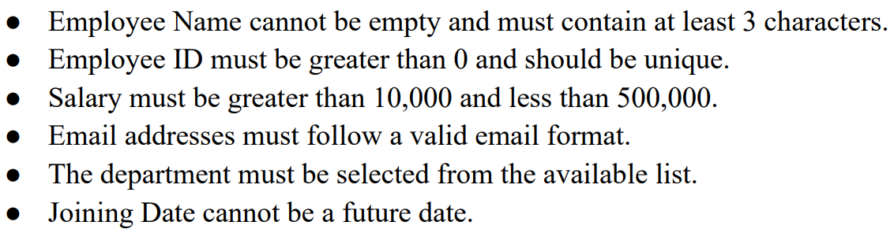

CC- Develop a College Management Lightning Application to store and manage student and faculty records. The system should ensure data accuracy using validation rules while creating or updating records. The system should validate the following before saving:
